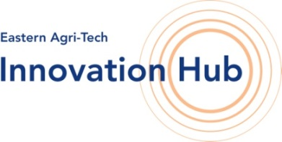
HUB CLUB MEMBERSHIP APPLICATION FORM
Apply online at www.innovationhubuk.co.uk

If you would like to become a member of the Hub Club Network
please complete this form and email or send to:
Contact/email details to:
Eastern Agri-Tech Innovation Hub Club
E: innovation.hub@niab.com
T: 01223 342227 or 01223 342454

Hub Club, Eastern Agri-Tech Innovation Hub

Hasse Fen, Hasse Road, Soham,

Cambridgeshire CB7 5UW

I/We would like to become a member of the Eastern Agri-Tech Innovation Hub Club BASIC membership. The cost of membership is £300 pa plus VAT:

Title: |  | Full name:
Trading title*:
Address
 |  | Postcode:
Telephone: |  | Mobile:
Email:*

Hub Club Criteria: Your business needs to be concerned with sustainable or innovative farming priorities and with reduction or re-use of all forms of waste in the food supply chain or improving resource use efficiency in its production. If you have any questions about your eligibility, please contact us. Please also see www.innovationhubuk.co.uk.

Description of your business and how this fits with the Hub Club Criteria…………...………………………………….……..
……………………………………………………………………………………………………………………………………………….……….....

……………………………………………………………………………………………………………………………………………….…….…….

……………………………………………………………………………………………………………………………………………….…………..

Date: |  | Signature
( e-signature or return a scanned copy)
Your business will have to fit with our Hub Club criteria and will therefore need to be approved first. On approval of your application you will receive confirmation by email with a link to our payment facilities.

For Office Use Only:

Membership approved by NIAB

Date…………………… Signature………………..………………………………………….

